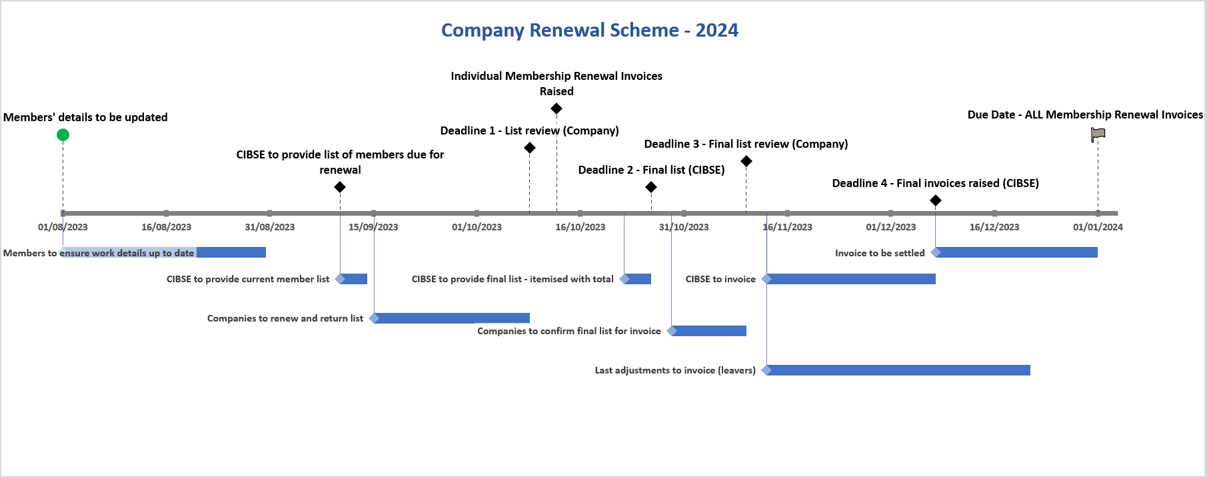
Actions |  |  |  |  | Key Activities & Deadlines
 | Start | End |  |  |  | Deadline Date
August | 01/08/2023 | 31/08/2023 | Members to ensure work details up to date |  | August | 01/08/2023 | Members' details to be updated
September | 11/09/2023 | 15/09/2023 | CIBSE to provide current member list |  | September | 11/09/2023 | CIBSE to provide list of members due for renewal
 | 16/09/2023 | 09/10/2023 | Companies to renew and return list |  | October | 09/10/2023 | Deadline 1 - List review (Company)
October | 23/10/2023 | 27/10/2023 | CIBSE to provide final list - itemised with total |  |  | 13/10/2023 | Individual Membership Renewal Invoices Raised
 | 30/10/2023 | 10/11/2023 | Companies to confirm final list for invoice |  |  | 27/10/2023 | Deadline 2 - Final list (CIBSE)
November/December | 13/11/2023 | 08/12/2023 | CIBSE to invoice |  | November | 10/11/2023 | Deadline 3 - Final list review (Company)
 | 13/11/2023 | 22/12/2023 | Last adjustments to invoice (leavers) |  | December | 08/12/2023 | Deadline 4 - Final invoices raised (CIBSE)
December/January | 08/12/2023 | 01/01/2024 | Invoice to be settled |  | January | 01/01/2024 | Due Date - ALL Membership Renewal Invoices

